* BitTorrent
  + Tracker:tracks peers participating in torrent
  + Torrent: group of peers exchanging chunks of a file.
* 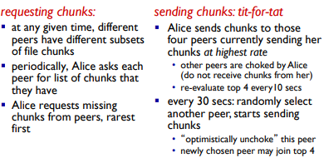
* Multimedia: video
  + Video: sequence of images displayed at constant rate
  + Digital image: array of pixels
    - Each pixel represented by bits
  + Coding: use redundancy within and between images to decrease # bits used to encode imge
    - spacial(within image)
      * Instead of sending N values of the same color(all purple), send only two values: color, value (purple), and number of repeated values (N)
    - Temporal ( from one image to next)
      * Instead of sending complete frame at i+1, send only differences from frame i.
  + CBR: constant bit rate - video encoding rate fixed
  + VBR: variable bit rate: video encoding rate change as amunt of spacial, temporal coding changes.
* Streaming multimedia: DASH
  + Dynamic, Adaptive Streaming over HTTP
  + Server:
    - Divides video file into multiple chunks
    - Each chunk sored, endowed at different rates
    - Manifest file: provides URLs for different chunks
  + Client:
    - Periodically measures server-to-client bandwidth
    - Consulting manifest, request one chunk at a time
      * Chooses maximum coding rate sustainable gien current bandwidth
      * Can choose different decoding rates at different points in time (depending on available bandwidth at time.
    - “Intelligence” a client: client determines
      * When to request chunk (so that buffer starvation, or overflow does not occur)
      * What encoding rate to request (higher quality when more bandwidth available
      * Where to request chunk ( can request from URL server that is “Close” to client or has high available bandwidth)
* Content distribution networks (CDNs)
  + 
   